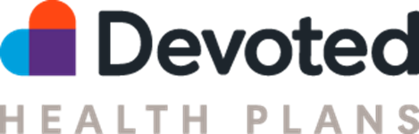

Upcoming Trainings
Post AEP Strategies
Join us during this webinar to build on your achievements and set the stage for an even stronger year ahead with the following topics:
- Reflecting on your accomplishments during AEP
- Learning valuable post-AEP preparation tips
- Reviewing our streamlined member onboarding process
- Understanding the OEP rules and guidelines
- Exploring all the resources available to support your continued success
  - Monday, December 9, 3 to 4pm Eastern time
  - Tuesday, December 10, 9 to 10am Eastern time
  - Wednesday, December 11, 12 to 1pm Eastern time
Register Here

New Agent Onboarding Live Webinar
Join our National Broker trainer Helen Gomez, CIC to learn all you need to know about Devoted Health. During this session you will hear about the Devoted Health difference, 2025 plan highlights, how to use our website, agent portal, Devoted Health sales process and more!
- Thursday, December 12, 9 to 10am Eastern time
- Friday, December 13, 3 to 4pm Eastern time
Register Here

