

📄 Enrollment Form Updates 📄
A new CMS question has been added: "Did you receive help filling out this enrollment application?”. This question is not meant to include the writing agent. If someone other than the writing agent helped the applicant complete the enrollment app, they should select "Yes" followed by one of the options from the drop-down list that describes the applicant’s relationship to the person that helped them (e.g., if another agent helped fill out the enrollment app, select "Agent" in the drop-down options). If no one other than the writing agent assisted the applicant, select "No".

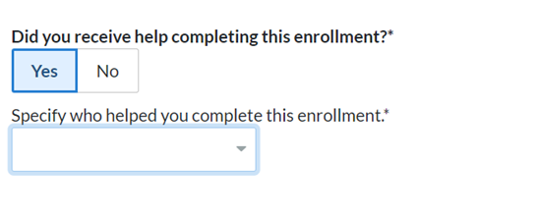
🏥 New Carriers/Plans 🏥
- Aetna C-SNP Plans NOW LIVE! If you use carrier-direct RTS, it will be automatically updated on the files we receive from them. ACTION: if you send us an RTS file (RTS2) then you will need to add "CSNP" to the product column.
- HCSC Medicare Supplements are now able to be live for enrollment directly in SunFire! Please make this request through your Account Manager and we will enable for you.
Quote and Enroll for these Plans:
- Humana Dental/Vision/Hearing: Any agent who has RTS for Humana MA plans will have access to enroll in these plans. If you use carrier-direct RTS, it will be automatically updated. ACTION: if you send us an RTS file (RTS2) then you will need to add "DVH" to the product column.
- Aetna Dental/Vision/Hearing: Any agent who has RTS for Aetna MS will have access to enroll in these plans. If you use carrier-direct RTS, it will be automatically updated. ACTION: if you send us an RTS file (RTS2) then you will need to add "DVH" to the product column.
Coming Soon:
- Aflac Dental/Vision/Hearing and UHC/Golden Rule Hospital Indemnity Plans
💲 Non Commissionable Plans 💲
We have been receiving questions surrounding non-commissionable plans (primarily PDPs) and whether SunFire will be suppressing these plans in the system. If a Carrier has decided to suppress a plan, it will not show for quoting or enrollment.
Any Carrier that has asked us not to suppress non-commissionable plans, and has identified the plan(s) as such, we now indicate 'Non-Commissionable' on the plan card (see image below).
- While most Carriers are providing non-commissionable status files, not every Carrier is supplying us a complete list. Therefore, we will only display the 'Non-Commissionable' flag for plans where Carriers have provided that information.
- These plans will have a green enroll button if the agent is RTS.
- If you would like to suppress any/all non-commissionable plans, you may do so by submitting a ticket in the Support Portal, but please know this will remove them from quoting and enrollment.
Non-Commissionable plans will not show on your DTC site or Agent PURLS.

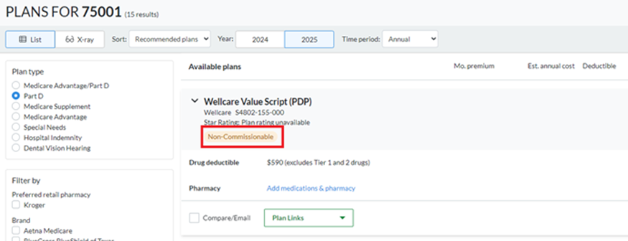
Thank you for your partnership with SunFire. We look forward to continued growth and success together. As always, reach out with any questions!


