
New: Look up your client’s Medicaid level and more
The Medicare & Medicaid Eligibility Lookup tool on Jarvis has been enhanced to provide you with more detail. Check out the new features that elevate the most important information front and center, including:
- View specific Medicaid level. Now, when you search using the Medicaid tab, you will see your client’s specific Medicaid level and waiver type for most states.* Plus, if you include a client’s Medicare number in your search, their Low-Income Subsidy (LIS) eligibility will also display.
- Dual Special Needs Plan (D-SNP) eligibility now displays on the Medicaid tab for plans for which a consumer qualifies. It also shows which plans may carry an Integrated Care Special Election Period (SEP) option, should the consumer qualify.
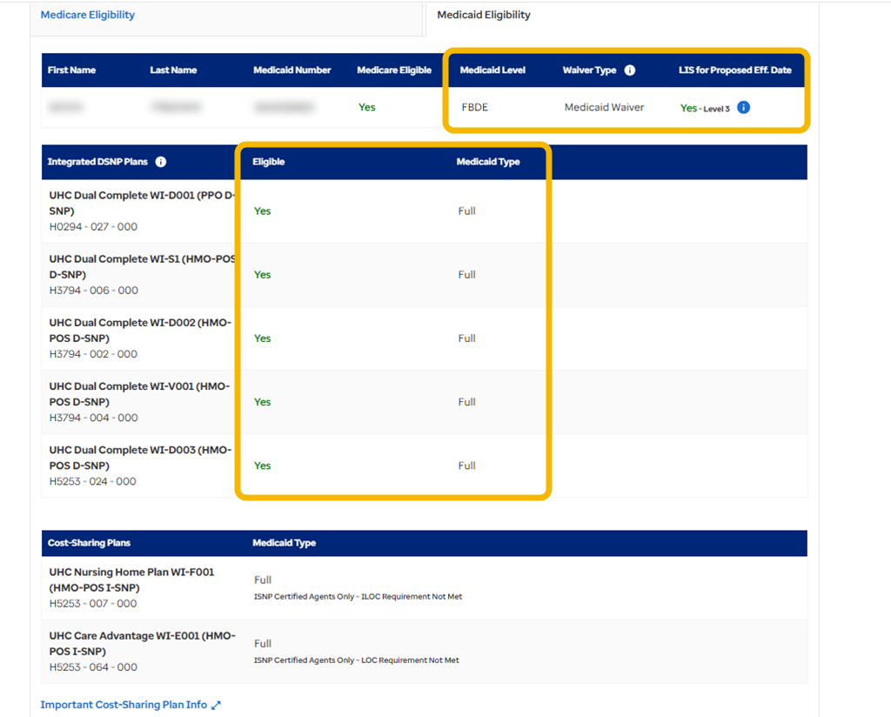
- On the Medicare tab, searching your client’s Medicare number will display their eligibility information for Parts A, B and D and their LIS status. And don’t forget you can then start a Medicare Advantage or Prescription Drug Plan application right from the Medicare results page to save you time.
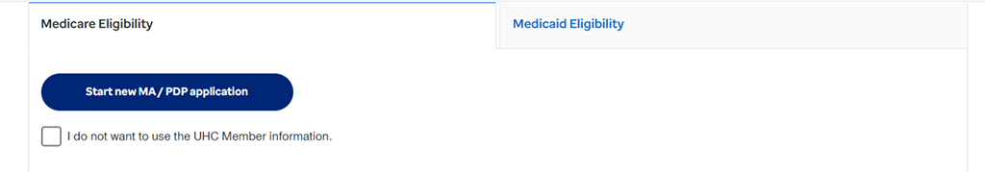
These updates are now available on your desktop and will be coming soon to your Jarvis app. Get familiar with the new features to prepare you for the changes to D-SNP SEP eligibility periods.

ACCESS THE LOOKUP TOOL

