Looking for Leads?
Take advantage of this TargetLeads deal!
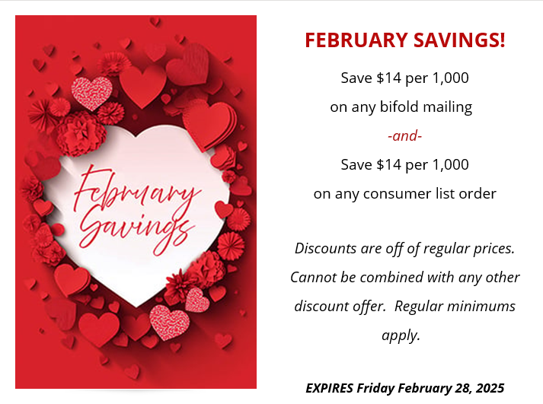

Click here to order a lead list or bifold mailing.

Lead lists can be phone lists, email lists, or addresses for mailing.
Questions? Reach out to MCC Brokerage for more information.

