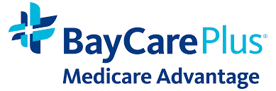
Storm-Related SEPs Remain Available

BayCarePlus Broker Partner,

Due to the concurrent Florida State of Emergencies (SOE) in our service area counties, storm-related Special Election Periods (SEPs) remain available.

The expiration date of this current SOE is currently July 13, 2025. Please expect the next update from us on July 1, 2025, or earlier.

Thank you!

Brad Lowe
Manager, External Sales

Producer Support
Phone: (833) 954-5893
Email: producer@baycare.org

Member Service
(866) 509-5396

Trust | Respect | Dignity | Responsibility | Excellence

