
Humana Enrollment Platform (HEP) - Launched TODAY!

We are happy to share that the Humana Enrollment Platform tool is now available via Vantage for our external agents. Agents should begin using HEP for enrollments today.

Attached, are step by step guides with instructions on how to complete enrollments. Although the guides are a little lengthy, the platform itself is very intuitive and easily mastered.

. Access Guides .

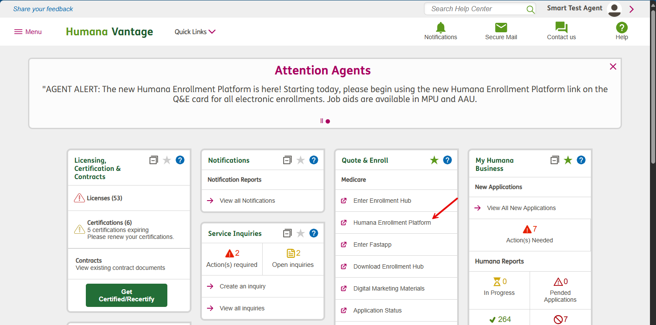

Important Reminders:
- Always capture language preference
- Capture member email address
- Detail for your member why checking the box YES for CenterWell Pharmacy Rx Consent is helpful for your member
- Select providers correctly by selecting the PCP number (DO NOT use NPI)
- Large Print- should only be selected when a member truly requires it. If selected, inform the member this option generates an excessive amount of additional paperwork that should be highlighted / considered.

