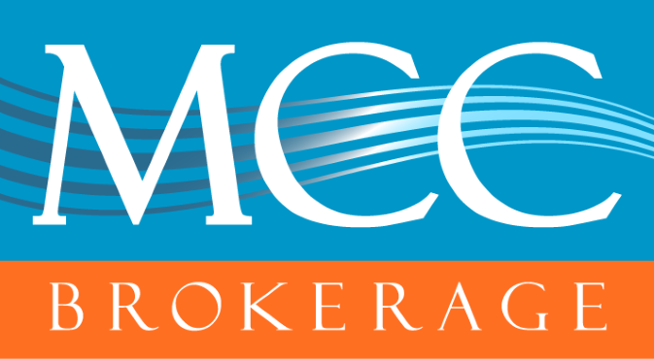

UHC MA Application Processing Delay
MCC Brokerage Updates

We’ve received notification that UnitedHealthcare (UHC) is currently experiencing processing delays for Medicare Advantage plan applications.
This delay is due to an issue with CMS and appears to just be affecting UHC at this time.
Please note: UHC is still actively processing applications—it may just take a bit longer than usual for confirmations and approvals to come through. No action is needed on your part at this time.
We’ll continue to monitor the situation and provide updates as we receive them.
If you have any urgent concerns or need assistance, feel free to reach out to us by calling 813-935-8361 or by emailing mcc@mccbrokerage.com
Thank you for your patience,
-The MCC Team

