Using Medigap to Combat the ‘Medicare Cliff’

Agents as Advocates: Using Medigap and MSP to Combat the ‘Medicare Cliff’
Health, Joe Brandau, Medicare/Medicare Advantage


Licensed agents who work with Medicare products are on the front lines of a significant shift in healthcare coverage affecting our most vulnerable consumers.
Recent data reveals a troubling trend: lower-income older adults transitioning from Medicaid to Medicare face a steep increase in out-of-pocket medical costs — from $2,600 annually to $3,100 within two years. Meanwhile, a 2021 report showed a strong correlation between consumer satisfaction with out-of-pocket costs and their general health.

Those in fair and poor health were 13% and 16.8% dissatisfied, respectively, compared to only 5.2% of those in excellent health reporting dissatisfaction with their out-of-pocket costs.
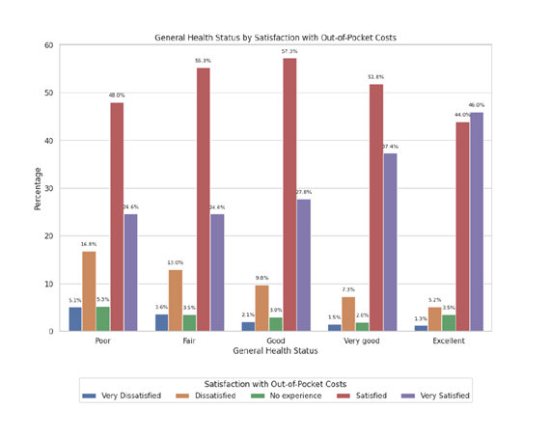
With these numbers on the rise, it’s time we find an effective strategy to help consumers navigate what’s known as the “Medicare cliff.”

Understanding the ‘Medicare cliff’
The “Medicare cliff” represents a critical juncture where individuals transitioning from Medicaid to Medicare encounter higher premiums, deductibles, and co-pays and a significant reduction in covered services.

Unlike Medicaid, Medicare does not cover long-term care, dental, vision, or hearing costs, leaving many to face these challenges with diminished resources. The transition is often marred by confusion due to conflicting notifications from Medicaid and Medicare, exacerbating the anxiety of those affected.

Strategic solutions: Medigap and MSP
To mitigate these challenges, licensed agents can explore underutilized resources with affected consumers, such as Medicare Supplement (Medigap) plans and the Medicare Savings Program (MSP).
Medigap plans can fill the gaps in Medicare coverage, providing the additional support needed to manage higher medical costs. However, the affordability of these plans can vary, making it essential to tailor advice to the financial situations of individual consumers.

Medigap plans offer:
- Gap coverage: Medigap plans help cover costs that Medicare does not, such as copayments, coinsurance, and deductibles, reducing out-of-pocket expenses.
- Additional benefits: Some Medigap plans cover services that Medicare doesn’t cover, like medical care when traveling outside the U.S.
- Predictable costs: By covering gaps in Medicare, Medigap plans provide a more predictable monthly expense, helping consumers budget better for healthcare costs.

The Medicare Savings Program remains markedly underutilized, yet it offers a lifeline by helping to cover premiums and out-of-pocket expenses. Encouraging enrollment in MSP can significantly alleviate the financial burdens faced during this transition.

The Medicare Savings Program offers:
- Financial assistance: MSP helps cover some out-of-pocket costs associated with Medicare, including premiums, deductibles, and coinsurance.
- Increased accessibility: Improving eligibility criteria and simplifying enrollment can increase participation, providing more comprehensive support.
- Educational outreach: Enhancing consumer education on the benefits and availability of MSP can lead to increased usage and offer significant financial relief.
Licensed agents can enhance their education efforts to empower more consumers to use these two solutions.

Expanding eligibility and simplifying processes
As an industry, we can advocate for policy changes that allow individuals facing the “Medicare Cliff” to maintain Medicaid eligibility as they transition. Expanding eligibility for aged, blind, and disabled (ABD) Medicaid and the MSP, simplifying the enrollment processes, and increasing funding for State Health Insurance Assistance Programs (SHIPs) could further support those we serve.

These challenges of the “Medicare Cliff” are daunting but not impossible. We can guide consumers through this transition by leveraging strategic solutions like Medigap and MSP and supporting policy reforms.

Takeaways
- Transitioning from Medicaid to Medicare can significantly increase out-of-pocket expenses and reduce health coverage.
- Utilizing Medigap and increasing enrollment in the Medicare Savings Program are effective strategies to mitigate these challenges.
- Policy change is needed to maintain Medicaid eligibility and simplify enrollment processes to provide substantial relief for those affected.

