SunFire: Multi-Factor Authentication
MCC Brokerage would like to share an important update on behalf of Sunfire.
To comply with carrier requirements, all SunFire users will be required to use Multi-Factor Authentication (MFA) to login to SunFire.
SunFire will transition to Multi-Factor Authentication (MFA) that will be going live on 6/1.
Tomorrow, agents will see the prompt below to pre-register for MFA in their profiles.
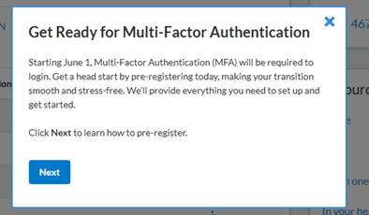
Pre-registering is not mandatory, but it will speed up their login experience on 6/1.
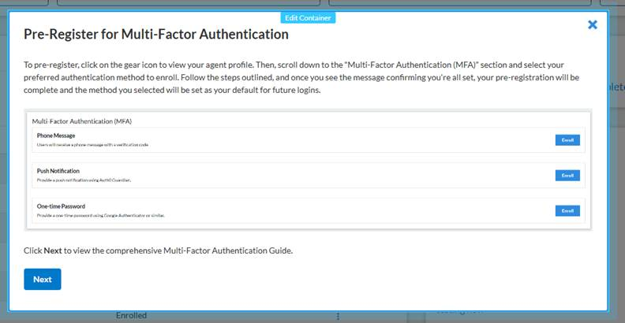
(continued below)
Agents will see the attached document that will provide them with additional details. It is accessible through the link pictured below.
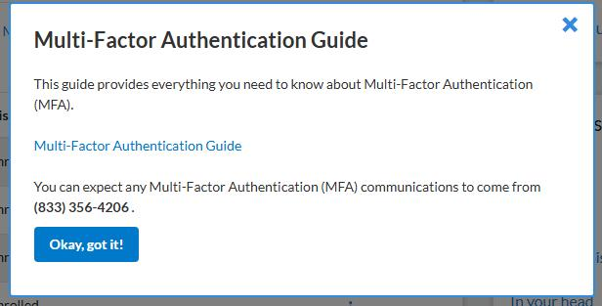
Agents may also CLICK HERE to access the document..
This is a carrier requirement and a best practice, and we appreciate the support as we make this transition.
If you have any questions about this change or SunFire, please reach out to MCC Brokerage at 813-935-8361 or email mcc@mccbrokerage.com.

