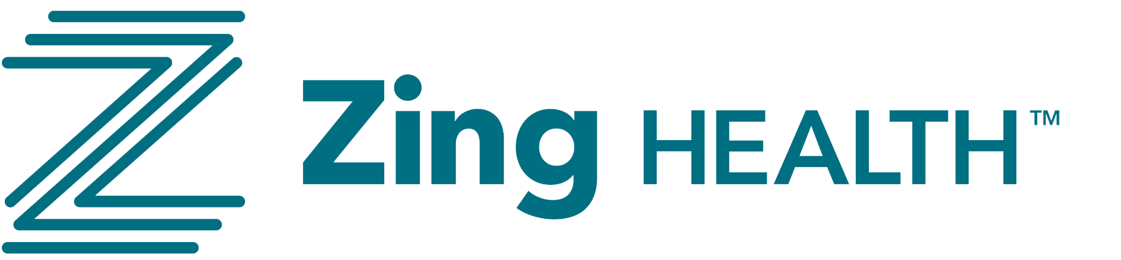

We’re excited to share that our 2026 First Look benefit grids are now available and attached for your review.
Important Reminder: These materials are strictly for partner use only and may not be shared publicly until October 1.
These grids will go live for agents on Monday, August 25 at zingfirstlook.com, so please bookmark that site as a go-to resource for plan details, grids, and sales materials.
2026 Highlights at a Glance
- 52 counties across 6 states
- $0 premiums on all plans
- No Part D deductible
- $0 Tier 6 C-SNP formulary, now including Monjourno
- Transportation benefit on all HMO plans
- ESRD members: $0 dialysis, $0 nephrologist visits, and unlimited transportation
- $100 HRA incentive continues on all C-SNP enrollments
- All plans are commissionable
Thank you for your continued partnership and support as we head into another successful AEP season together.

