
How to track your marketing material order

PURPOSE: This job aid will show you how to track your marketing material order for PY2026.

Click the Agent Order Link | NOTE: The order system will open for 2026 material ordering July 11th for New Certs and Recerts. Order by 8/15 to ensure materials are received by 9/30.  Materials will begin to ship 9/15
  https://printandfulfillment.adp.com/HumanaDelegatedAgents/Forms/UniversalLogin.aspx
Login  Step 1  Step 2  Step 3 | 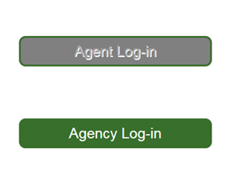  If agent click Agent Log-in  If agency click Agency Log-in  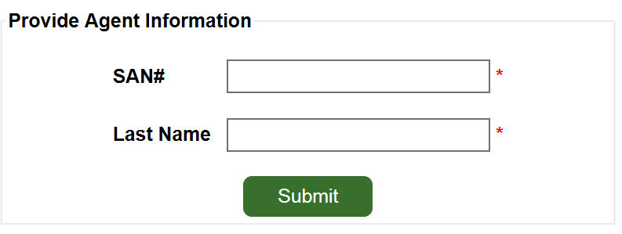  Enter SAN  Enter Last Name  Click Submit  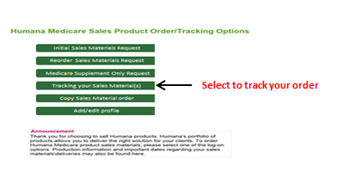
Choose look up option | 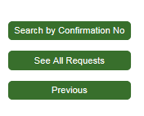  Search by Confirmation No  See All Requests
Review Tracking info | 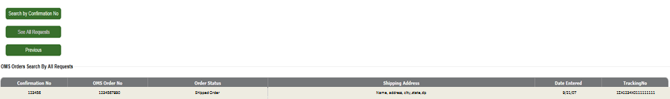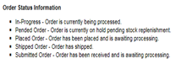  Click on OMS Order No to view order details  Tracking Status  Click on Tracking No  to view shipping info

